**Gurgaon Flat Price Prediction Web Application**

Name-Biplab Bijoy Mahato

Date-18/06/24

**1.Context and Background:**

Gurgaon, also known as Gurugram, is a rapidly growing city in the National Capital Region (NCR) of India. Over the past decade, Gurgaon has transformed into a major hub for corporate offices, commercial activities, and residential developments. This rapid urbanization has led to significant fluctuations in real estate prices, making it challenging for potential buyers, sellers, and investors to make informed decisions. A reliable flat price prediction tool is essential for stakeholders to navigate the dynamic real estate market in Gurgaon**.**

**2.Problem:**

The primary problem is the lack of accessible, accurate, and real-time predictive tools for flat prices in Gurgaon. Traditional methods of property valuation often involve manual processes, reliance on historical data, and subjective judgments, which can lead to inconsistencies and errors. These traditional methods fail to account for the rapidly changing market conditions, the impact of infrastructure development, and other macroeconomic factors affecting property prices.

**3.Objectives:**

The main objective of this project is to develop a web application that accurately predicts the prices of flats in Gurgaon using advanced machine learning algorithms. The application should:

1. **Integrate Diverse Data Sources:** Utilize a combination of historical price data, geographic information, market trends, and economic indicators.
2. **User-Friendly Interface:** Provide an intuitive and interactive interface for users to input specific details about the property and receive real-time price predictions.
3. **Scalability:** Ensure the application can handle a large volume of user queries simultaneously and is scalable to include more regions in the future.
4. **Accuracy:** Continuously update and improve the predictive models to enhance accuracy as more data becomes available.

**4.Target Specification and Characterization:**

**Target Specification**

Target specification refers to defining the precise requirements and goals that the web application must meet to be considered successful. It involves setting clear, measurable, and achievable criteria that guide the development and evaluation processes. For the Gurgaon Flat Price Prediction Web Application, the target specifications can be divided into functional, non-functional.

**Functional Requirements**

1. **User Input Interface:**
   * Allow users to input property details (e.g., location, size, number of bedrooms, amenities).
   * Provide options for users to specify additional factors (e.g., age of the building, proximity to metro stations).
2. **Data Processing and Prediction:**
   * Use machine learning models to process user inputs and predict property prices.
   * Display predictions with a confidence interval and comparison to similar properties.
3. **Data Integration:**
   * Aggregate data from multiple sources, including real estate listings, market reports, and government records.
   * Ensure data is regularly updated to maintain prediction accuracy.
4. **User Feedback Mechanism:**
   * Allow users to provide feedback on the predicted prices to improve the model over time.
   * Include a feature for users to report errors or inconsistencies.

**Non-Functional Requirements**

1. **Performance:**
   * Ensure the web application can handle a high volume of user queries simultaneously without significant latency.
   * Optimize the response time for predictions to be under 5 seconds.
2. **Scalability:**
   * Design the system to be easily scalable to include additional regions or property types.
   * Ensure the architecture supports future enhancements and increased data volume.
3. **Usability:**
   * Create an intuitive and user-friendly interface that is easy to navigate.
   * Ensure the application is accessible on various devices, including desktops, tablets, and smartphones.
4. **Security:**
   * Implement robust security measures to protect user data and prevent unauthorized access.
   * Ensure compliance with relevant data protection regulations.

**Characterization**

Characterization involves assessing how well the web application meets the defined target specifications and identifying areas for improvement. It includes performance testing, user feedback, and iterative refinement of the application.

**Performance Testing**

1. **Load Testing:**
   * Simulate high volumes of user traffic to ensure the application can handle peak loads.
   * Measure response times and system behavior under stress.
2. **Accuracy Assessment:**
   * Validate the machine learning models using historical data and real-time inputs.
   * Compare predicted prices with actual market prices to assess accuracy.
3. **Usability Testing:**
   * Conduct user testing sessions to gather feedback on the interface design and user experience.
   * Identify and address any usability issues.

**User Feedback**

1. **Feedback Collection:**
   * Implement tools to collect user feedback on predictions and overall experience.
   * Analyze feedback to identify common issues and areas for improvement.
2. **Iterative Improvement:**
   * Regularly update the machine learning models based on new data and user feedback.
   * Enhance the application interface and functionality based on user suggestions.

**Continuous Monitoring and Updates**

1. **Monitoring:**
   * Set up monitoring tools to track application performance and usage patterns.
   * Detect and resolve issues promptly to ensure smooth operation.
2. **Updates:**
   * Release regular updates to incorporate new features, improvements, and security patches.
   * Communicate updates to users to keep them informed of new functionalities.

By clearly defining target specifications and systematically characterizing the application, the Gurgaon Flat Price Prediction Web Application can be developed to meet user needs effectively and adapt to the evolving real estate market conditions.

**5.External Search(information sources)**

I collect This Data by web scraping from the site 99acres.com.

About The Site:-

One of India's first online platforms to cater to the real estate market, 99acres.com has a pan India listing of properties for sale, purchase and rent, spanning 25 plus cities. Catering primarily to real estate developers, builders and brokers, 99acres.com uses property listings, builders' and brokers' branding and visibility through microsites, home page links and banners to bring together and connect builders, brokers, dealers and interested buyers/sellers.

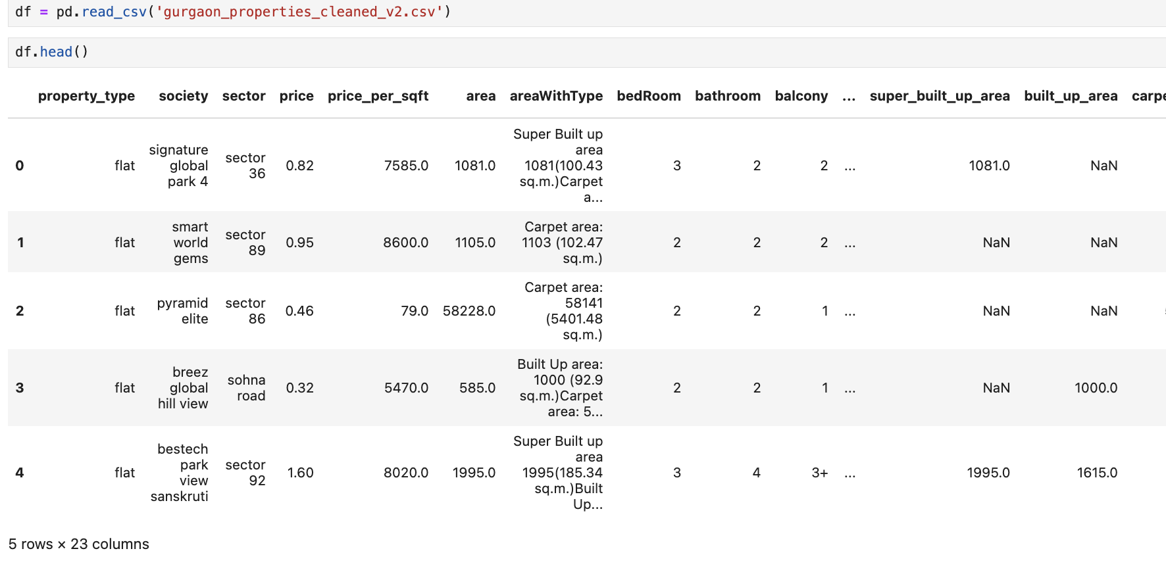

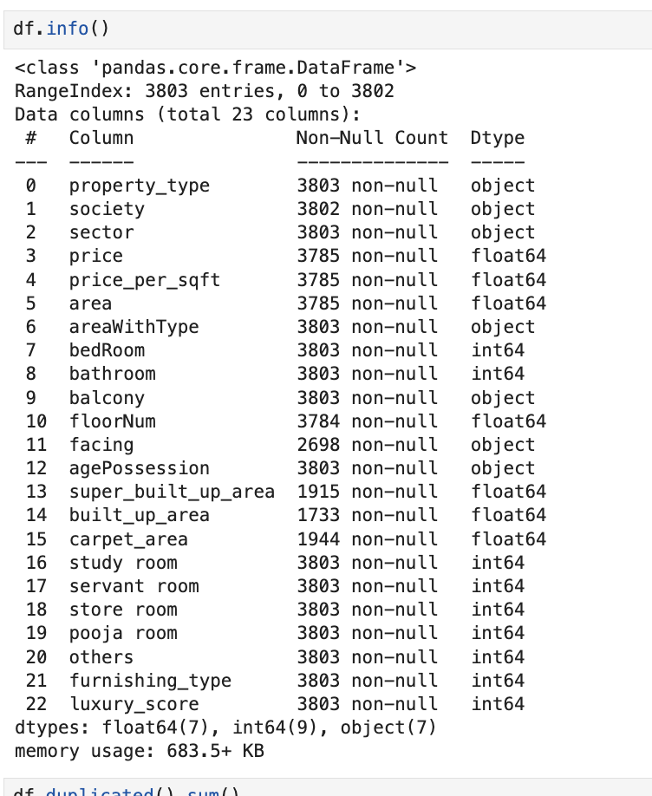

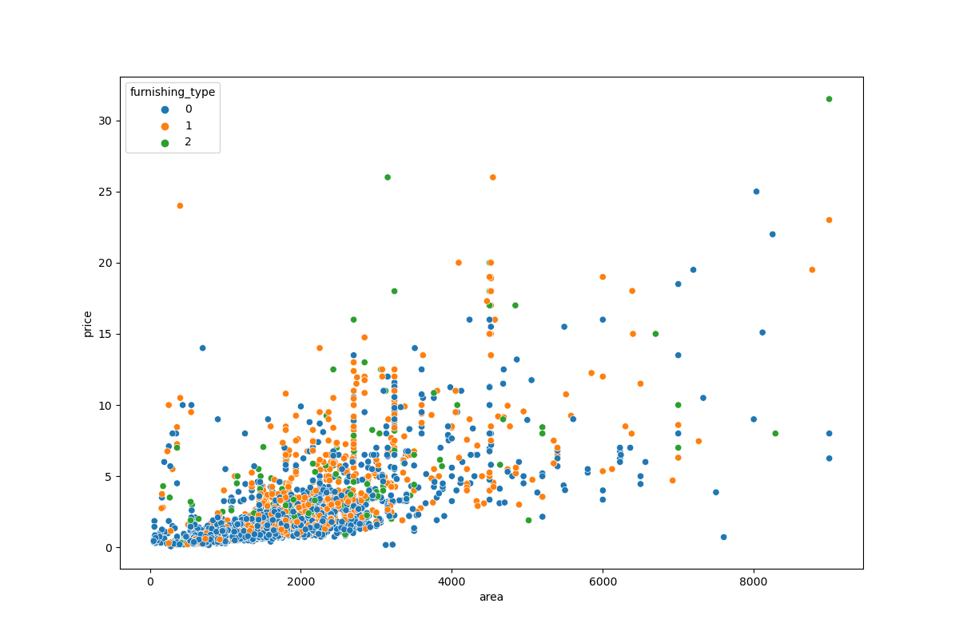**6.Benchmarking**:

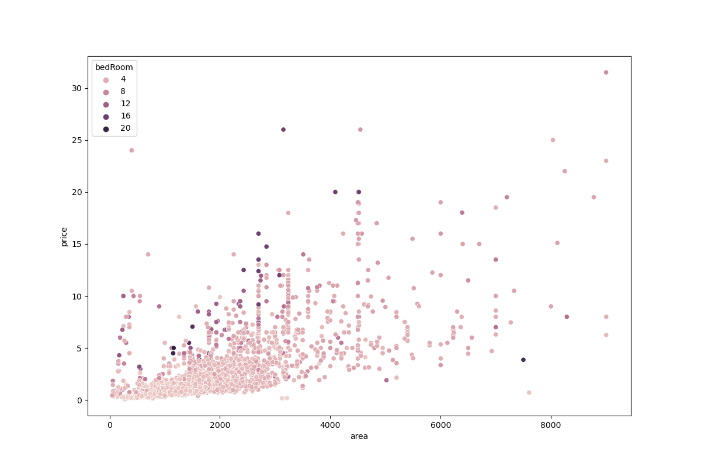

Correlation Matrix For Flat Dat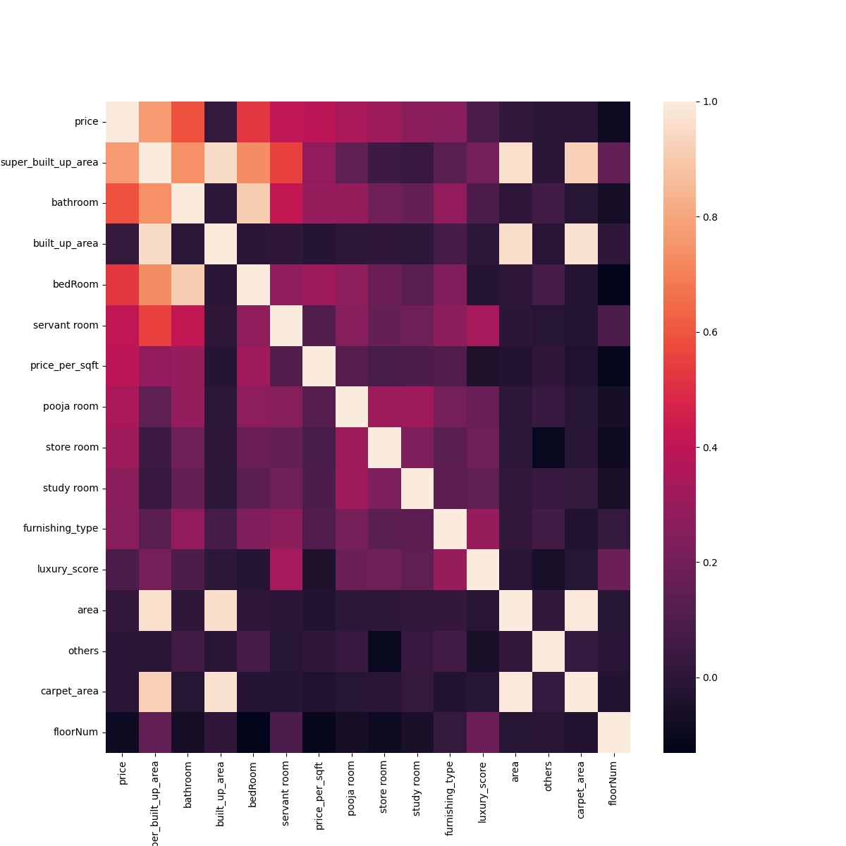a

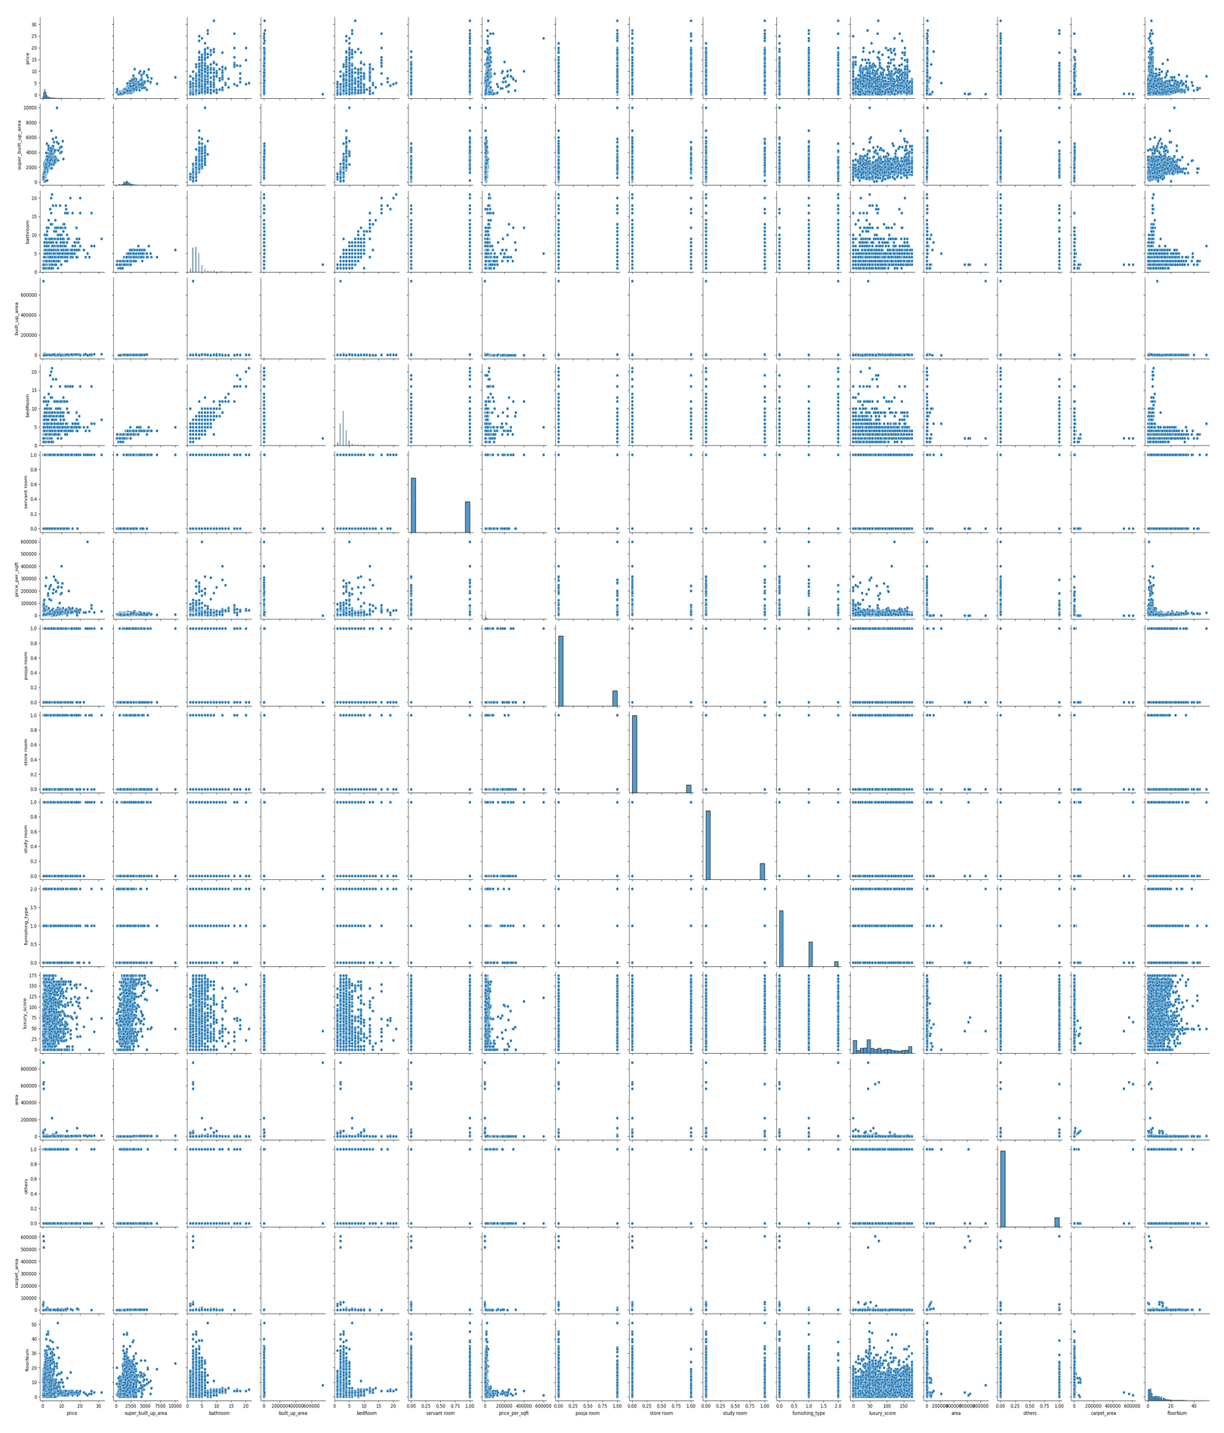**Pair Plot**

**7.Business Opportunity :**

Gurgaon is a rapidly growing city with a dynamic real estate market driven by corporate development and increasing demand for residential properties. There is a critical need for accurate, accessible, and real-time price prediction tools to assist buyers, sellers, investors, and real estate professionals in making informed decisions.

It addresses a significant market need, offering a technological, user-friendly, and scalable solution. By targeting a diverse audience and generating multiple revenue streams, the project promises long-term sustainability and growth in the rapidly evolving real estate market.

**8. Concept Generation**

This product requires the tool of machine learning models to be written from scratch in order to suit our needs. . Tweaking these models for our use is less daunting than coding it up from scratch. A well trained model can either be repurposed or built. But building a model with the resources and data we have is dilatory but possible. The customer might want to spend the least amount of time giving input data. . This accuracy will take a little effort to nail, because it’s imprudent to rely purely on Classic Machine Learning algorithm.

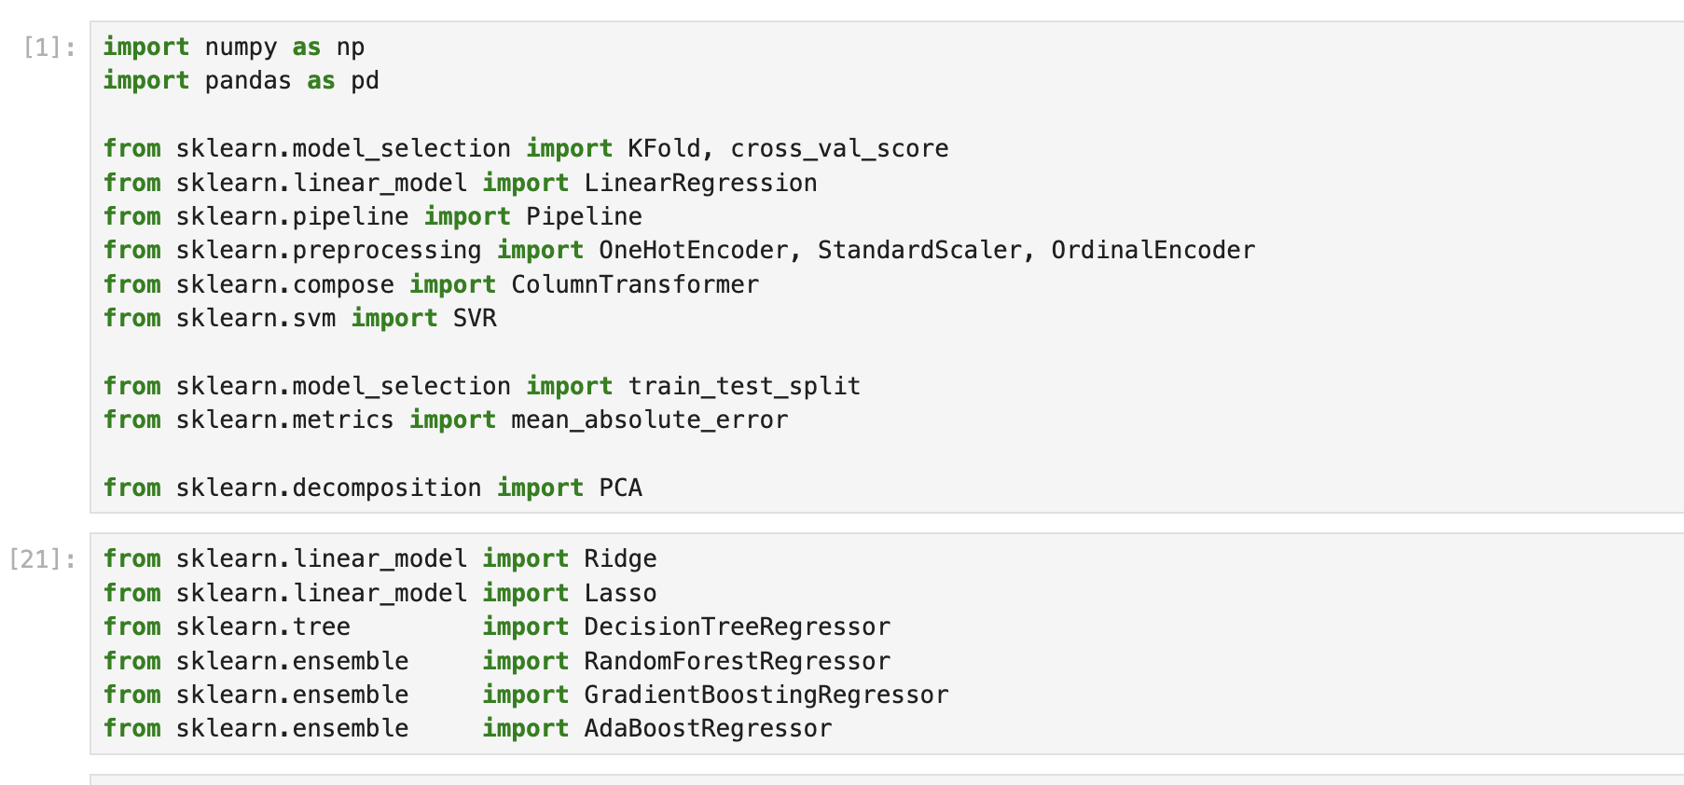

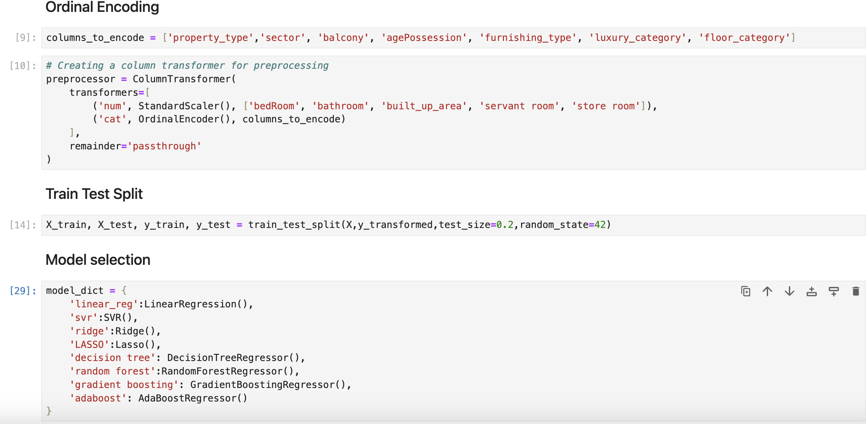

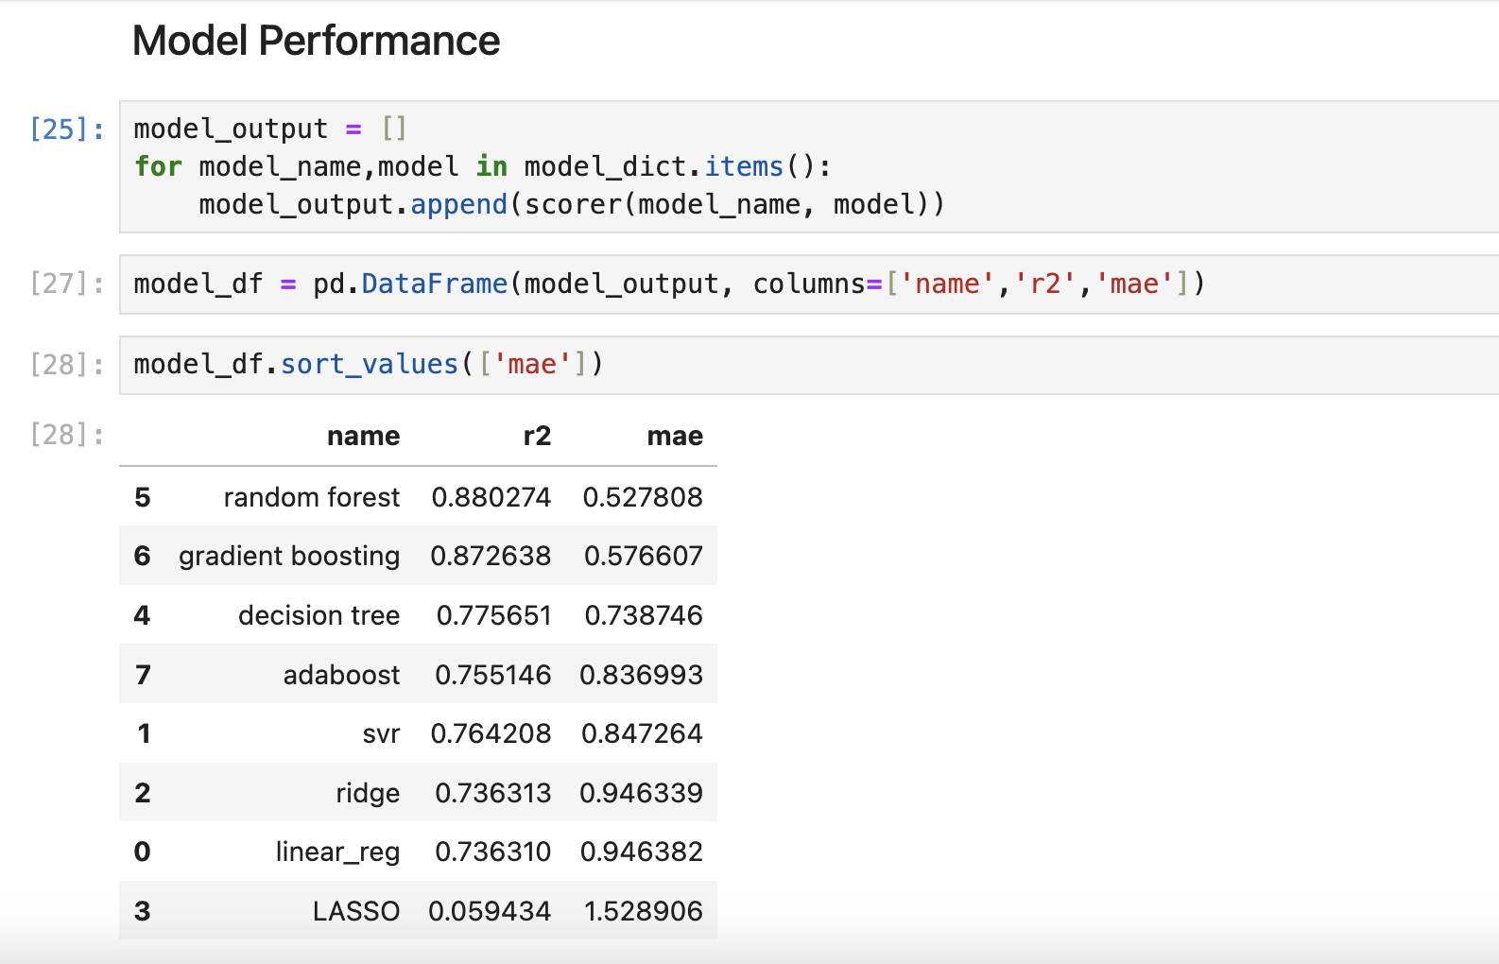

So We Finalize Random Forest. Model For Our Model Training And Model Deployment as its accuracy is higher than others.

**9. Concept Development:**

The concept can be developed by ,**Streamlit** Python framework .This basic structure sets up a Streamlit application that predicts flat prices in Gurgaon based on user inputs. It can further refine the model, enhance the UI, and add more features as neededThe cloud services has to be choosen accordingly to the need.

**10. Final Report Prototype**

The product takes the following functions to perfect and provide a good result.

Back-end :

Model Development: This must be done before releasing the service. A lot of manual supervised machine learning must be performed to optimize the automated tasks.

1. Performing EDA to realize the dependent and independent features.
2. Algorithm training and optimization must be done to minimize overfitting of the model and hyperparameter tuning.

Front End:

The user must be given many options to choose form in terms of parameters. This can only be optimized after a lot of testing and analysis all the edge cases.

**11. Product details:**

My web application Interface is given below.

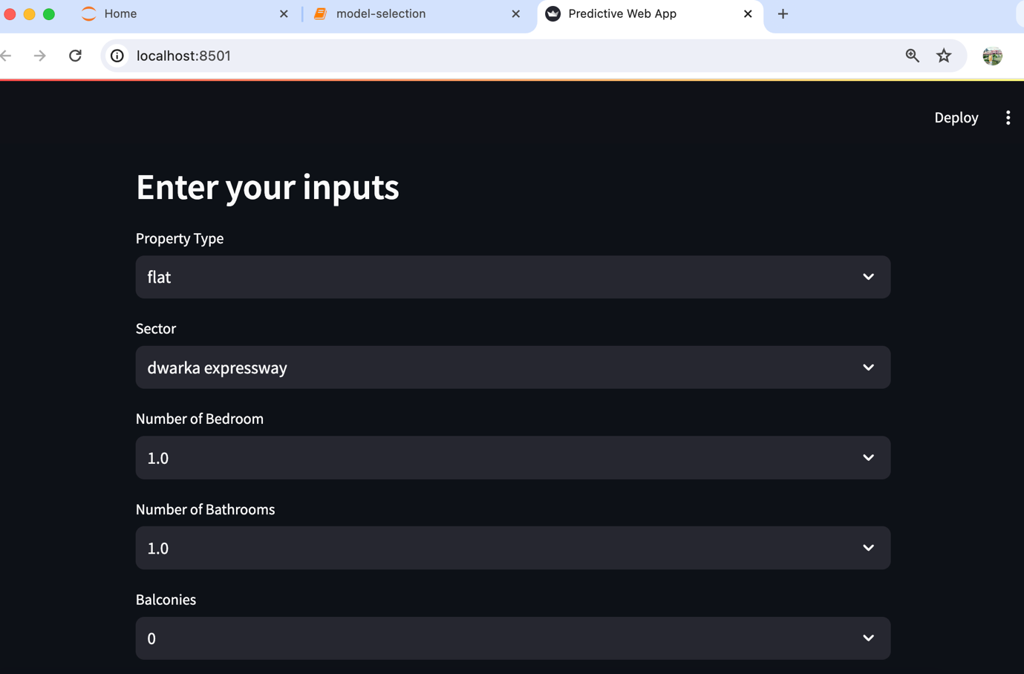

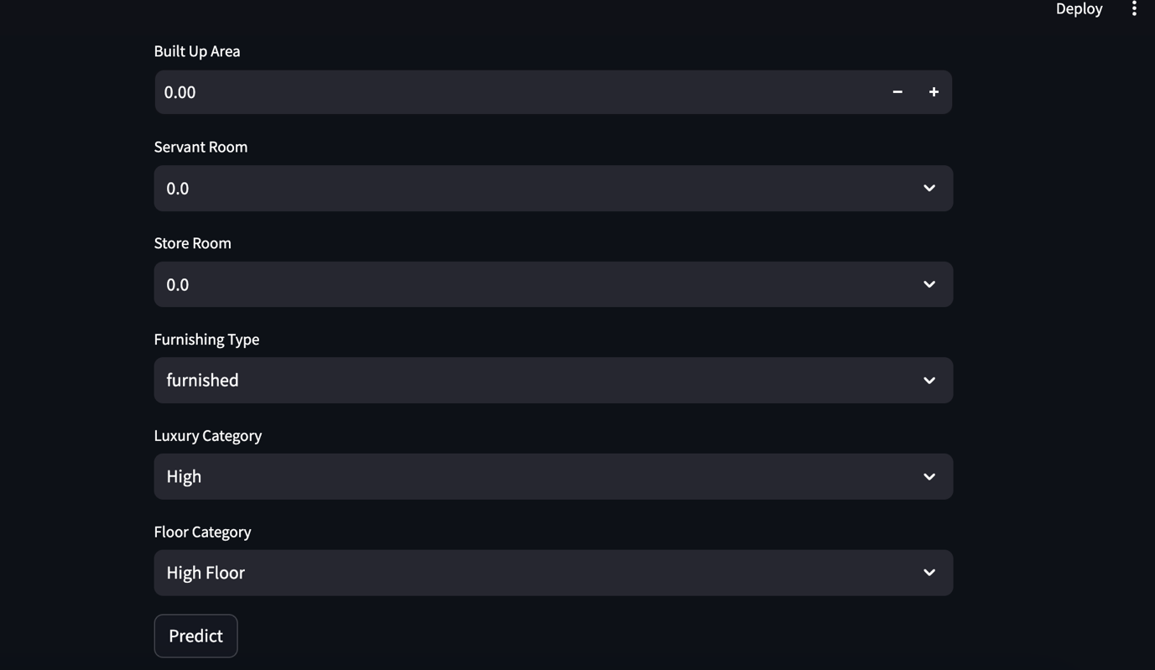

**12. Conclusion:**

The Gurgaon Flat Price Prediction Web Application project leverages advanced machine learning algorithms integrated into a user-friendly Streamlit framework to provide accurate and real-time property price predictions. This innovative tool addresses a critical need in the rapidly growing real estate market of Gurgaon, offering significant value to individual buyers, sellers, investors, real estate agents, and developers.

The successful deployment of this application can transform the way stakeholders navigate the real estate market, providing them with a powerful resource for making informed decisions. The diverse revenue streams, including subscription plans, premium features, targeted advertising, data insights sales, and consulting services, promise a sustainable business model with significant growth potential.